Smart Agriculture Crop Yield Prediction Using Dynamic Programming and Data Modeling

Problem Statement
Modern agriculture depends on several environmental factors such as rainfall, temperature, soil quality, humidity, and fertilizer usage. Variations in these factors affect crop production. Therefore, an intelligent system is required to predict crop yield accurately and help farmers make better decisions regarding irrigation, fertilizer application, and harvesting schedules.

Introduction
Smart Agriculture integrates technology and data analysis to improve crop productivity and resource utilization. Crop yield prediction enables farmers to estimate production in advance and minimize losses.Dynamic Programming helps optimize repeated computations, while Data Modeling establishes relationships between environmental factors and crop production.

Environmental Factors Considered
Factor | Description
Temperature | Average temperature during crop growth
Rainfall | Amount of rainfall received
Soil Quality | Fertility and nutrient content
Humidity | Atmospheric moisture level
Fertilizer Usage | Quantity of fertilizer applied
Water Availability | Irrigation resources

ALGORITHM :
Weather Variability
- Rainfall patterns change unpredictably.
- Extreme temperatures may reduce crop productivity.
Soil Conditions
- Different soil types produce different yields.
- Nutrient deficiencies affect plant growth.
Resource Limitations
- Water availability may be limited.
- Fertilizer cost and accessibility vary.
Large Data Volume
- Large farms generate massive datasets that require efficient processing.
PROGRAM:
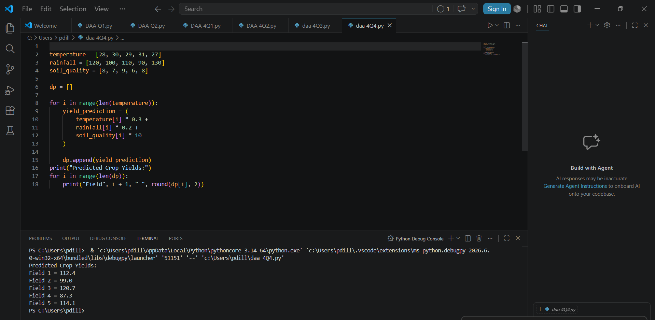

Suggested Tools and Platforms
- Python
- Visual Studio Code
- Jupyter Notebook
- Pandas
- NumPy
- Scikit-learn
- TensorFlow
- GitHub

Scalability for Large Farms
The model can be expanded to support:
- Multiple agricultural fields
- Large datasets
- IoT sensor networks
- Cloud-based farming systems
- Precision agriculture applications
Dynamic Programming improves scalability by reducing computational overhead.

Performance Analysis
Complexity Type | Value
Time Complexity | O(n)
Space Complexity | O(n)
Where:
- n = Number of observations or records.

Efficiency Evaluation
Advantages of the system include:
- Faster prediction.
- Reduced computational cost.
- Improved resource utilization.
- Better agricultural decision-making.
- Increased productivity.

Interpretation in Agricultural Planning
Crop yield prediction helps farmers:
- Estimate future production.
- Plan irrigation schedules efficiently.
- Optimize fertilizer usage.
- Reduce crop losses.
- Increase profitability and food security.

Conclusion
Dynamic Programming combined with Data Modeling provides an efficient and scalable approach for crop yield prediction. By analyzing environmental factors and optimizing computations, smart agriculture systems can improve productivity and support sustainable farming practices.

References
- Thomas H. Cormen, Introduction to Algorithms.
- Data Structures and Algorithms Using Python.
- Machine Learning with Python.
- Smart Agriculture and Precision Farming Research Papers.

